CaBench-to-Bedside (caB2B) Design Architecture

Usecases to demonstrate the need of caB2B Server:

User creates a query/workflow which takes say half a day to return. User submits that for processing and closes the caB2B application. Then there should be some mechanism running behind which will take care of processing the query and storing the result and then when user logs in next time it will notify the user about the result of query execution.

- The lab with multiple caB2B clients installed on different machines should facilitate the user to use central lab database as caB2B local database, to store their work and use it over high speed intranet.

- A user should be able to access the private data and private notification by using any one of the local clients.

- The database bottleneck, caused due to sharing should be tackled by caching appropriate data.

- Benefits
  - This avoids installing database per client.
  - It saves space as common data can be stored once and will be shared by all users.
  - Common data which needs to be refreshed periodically from some source external to cab2b e.g. caFE. This will be faster as it happens at one place only.
  - If user has selected that update my saved data (say sample information) regularly, and then it is very easy as updation is happening at one location only.

- Losses
  - If the user wants single machine installation, then client will be loaded due to additional implementation, which is not needed.
  - User can’t take his data along with him.
  - Increases network overhead. This will happen even if there is not caB2B server, but all clients are connecting to shared-database.

What should the caB2B server support?
- Asynchronous execution of jobs.
- Notification mechanism.
- C, R, U, D operations on all caB2B objects.
- Cache common data and make it available to everyone.
- Cache user private data and make it available to the specific user only
- Common data refresh mechanism (compulsory)
- User data refresh (by user choice)
- Support “scheduled queries”

Implementation:
Add a layer running between clients and database which will acts as a local caB2B server. It handles processing workflows/queries asynchronously and stores the results. It will also maintain the information about result of execution along with the user information. This helps in notifying the user about executions results, when user logs in next time. Database accessing layer will be moved to this layer. The caB2B server can run on the same machine on which database is installed. This is similar to a client server application’s need, so there can be an application/web server on which the caB2B server is running,it helps in implementation of caching, asynchronous executions etc.

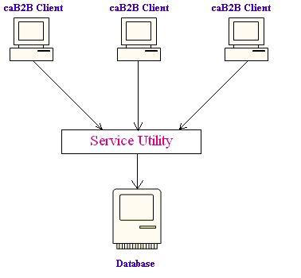
Pros:
- Common data like system trees can be cached once and shared by all users.
- All benefits of client-server architecture, that is

  - If number of clients increase then just one machine (on which caB2B server is running) needs up gradation to maintain performance level.
  - Updates in the caB2B server itself (like change in caching strategy) need to be installed at one place and it is availed to all clients.
  - User can logs in from different machine rather than his regular machine and still gets the same performance; because system cache will respond to it uniformly due to central cache.
  - Clients will be less loaded as caB2B server is running on some different machine.

Cons:
All the losses of client-server architecture:
  - If this caB2B server is down then it will halt all client working.
  - As database CRUD operations are in caB2B server, an additional mechanism (sort of RMI) is needed which enables clients to call these.

Data Eligible for caching
- Static Data
This is data which is fixed over certain period. Caching these will help in having better response to user when he navigates through system or clicks on history. It can be further divided into two parts.

  - Data not edited by caB2B system.
These should be loaded once and will remain cached till next refresh. E.g. default categories, System Trees
  - Data edited by caB2B system.
These should be loaded once and will be cached again when it is updated. E.g. Search History, Default Categories, default views

- Objects user currently editing (Experiment, Query)
This is user’s private data. User may save intermediate work and continue after weekend. Caching this data helps in having better user response when user logs in next time. The incomplete work will be already there in cache. Life of this cache can span over a week. E.g. experiment created by user, category defined by user, my categories.

- Data which changes rapidly should not be cached. E.g. Popular categories which changes per user access.
We can do in memory operations and then save it to database once a day

To make it work:
Every database access should go through service API only. That is no part outside the caB2B server, should access database. If INSERT/UPDATE is fired then the cache is modified by the saved/modified objects. This will keep the cache up to date and will improve performance as modified data has more possibility of being accessed after modification. If the query is SELECT type then it is candidate whose results can come from cache.

Miscellaneous
We can have a hybrid of implementation of approach 1 and 2 to get the best out of it. Cache the user specific data in client cache. This data can be temporarily “swapped out” to caB2B server cache (e.g. if many users use same machine). But store common data in the caB2B server cache only (we can think of a second level cache at clientside based on user pref, which would depend on client machine memory etc…)

Architecture of caB2B
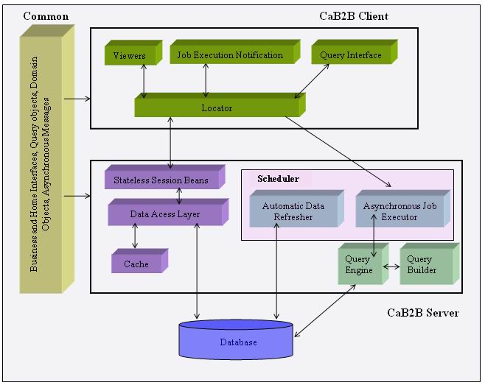
All modules are divided into three parts, caB2B client, caB2B server and common.
All the methods dealing with database will be defined in business interfaces in common part.

Server side code will have implementation of these methods in the form of EJBs.
This also means that server code should be compilable without client code. Server will also have code for refreshing database periodically; execute jobs and storing results, notifications. It will also take care of caching the data.

Client will have code for viewers, query Interface, locator etc…. This locator will take care of locating the beans/resources. This also means that client code should be compilable without server.

Let’s take a usecase to understand
User says save an Experiment object.

So the code will go as follows:
- Experiment is the domain object.
- There will be a ExperimentBusinessInterface with method
save(Experiment obj). It will go in common part.
- There will be an EJB, ExperimentBean, which implements ExperimentBusinessInterface. It goes in caB2B server part.
- Home interface of the bean will be ExperimentHomeInterface and it will be in common part. Bean’s RemoteInteface will extend ExperimentBusinessInterface.
- UI will ask locator to give me class for saving an experiment. Locator will lookup the ExperimentHomeInterface and will call create() on it.
It will return ExperimentBusinessInterface. UI will call save(Experiment obj) on it. Bean’s implementation will perform business logic on the object and then calls appropriate DataAccessObject class to save the object. DAO, after saving the object, will put it in cache.

User says get an Experiment object
So the code will go as follows:
- There will be a ExperimentBusinessInterface with method
getExperiment(experimentName). It will go in common part. It returns list of Experiment domain objects.
- There will be an EJB, ExperimentBean, which implements ExperimentBusinessInterface. It goes in caB2B server part.
- Home interface of the bean will be ExperimentHomeInterface and it will be in common part. Bean’s RemoteInteface will extend ExperimentBusinessInterface.
- UI will ask locator to give me class for fetching experiment. Locator will lookup the ExperimentHomeInterface and will call create() and it will return ExperimentBusinessInterface.
QueryInterace UI will call getExperiment(experimentName) which will return the experiment.

We will be using following tools
- JDK 1.5 (caGrid needs)
- mySQL 4.1
- Eclipse 3.1.1 (for JDK 1.5)
- apache-ant-1.6.5 ( Starting with Ant 1.6.2 supports JDK 1.5).
- Jboss 4.0.0 (http://wiki.jboss.org/wiki/Wiki.jsp?page=JBossVsJavaJDKVersionMatrix)

List of targets in build.xml
clean.all
compile.all, compile.client, compile.server
run.unittest
client.jar, server.jar
build.ear
deployToJboss
javadoc

Folder Structure
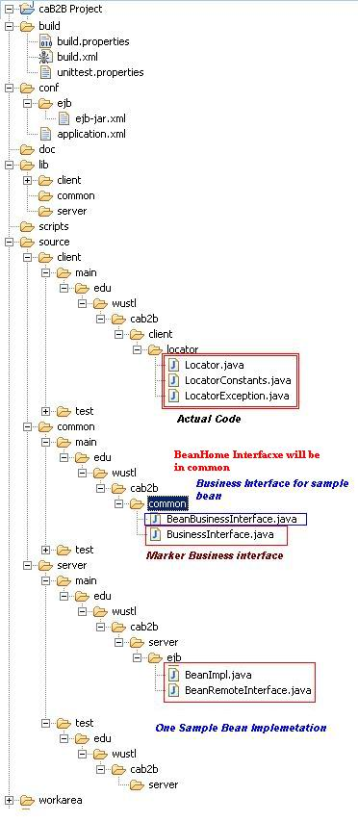 | build: Holds all build related resources like build.xml, build.properties, unittest.properties  conf: Holds the deployment descriptors other property files.  doc: Holds generated java docs  lib: all the external jars needed for caB2B  scripts: holds the SQL scripts  source:  The structure of source is such that iot facilitates selectively working on client/server or main/test  source/client: Holds all the code which will go in client and the unit tests for the same. Like viewer, locator etc  source/common: Holds all the code which will go in common and the unit tests for the same. Like BusinessInterfaces of beans  source/server: Holds all the code which will go in server and the unit tests for the same. Like bean implentations, Bean’s home etc  workarea: Holds all the files generated by build process other than javadoc. This is a temporary storage.

Things to note while coding
- Beans will go in *.ejb package

- For each bean, the following four files need to be written
  - business interface of bean in which each method throws remoteException
  - Implementation of bean. This will implement business interface
  - Write Remote interface extending bean’s business interface
  - Home interface for that bean having create() method which returns remote interface of bean.

Also register the new bean to ebj-jar.xml. Here <ejb-name> will be a fully qualified name of bean class

- All Beans should extends edu.wustl.common.bizlogic.AbstractBizLogic
- All business interfaces must extend a marker interface BusinessInterface

- No class other than Locator should look up beans. Locator will be a singleton class and its locate() method returns BusinessInterface.

- Need to finalise exception handling framework -- base exception,exception constants

- A class will hold all bean names as constants. and whenever ejb-jar.xml is edited the corresponding constant needs to be edited

- Data Access Layer will reuse DAO layer of common package
- Unit test cases for client side will be JUnit
- Unit test cases for server side will be JUnit + cactus

Sample ejb-jar.xml
